**Top 10 applications for music streaming**

Topmost sources for entertainment and mind refreshing for any journey, or work-break or any other break is listening to music! From Android to iOS, PC to tablets, and mobile phones, every device has several options for music streaming and live streaming with various other features that provide access to the new releases for entertainment.

Melodious jingles and tunes provide a melodious mind working!

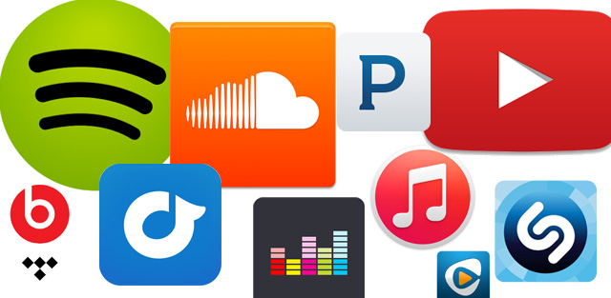

The music streaming is supported by millions of apps that have various features like developing a playlist, downloading the songs for offline access, and having the list according to the artist, DJ's, events, and albums. From National to International, every song is available in these music streaming applications. Several applications are there that provide free streaming and services, whereas, a few of them charge a small amount of money for a subscription to have access to the whole of their services.

Top 10 music streaming applications that are available for Android and iOS are the following:

**Spotify**

Spotify is the most trendy application for music streaming that has been at the peak in these days. It has various options for searching the favorite songs and artists of various languages and albums, and you can also design a customized playlist. These playlists can also be shared. Various new releases are there too in this free application that has some in-app purchase that ensures Ad-free streaming. This is available for both iOS as well as Android and has playlists based on top trendy monthly or weekly releases and ratings.

**Gaana music**

Gaana is a 4.6-star rated application that has more than 100 million downloads and is a free application for Android as well as iOS. It has high-quality HD music with the latest releases, and there are various songs available that can be selected as favorite and transferred to the customized playlist. The app also releases its playlist that is provided by the experts based on the newest releases and trends, and lyrics of the songs are also available. There are radio and podcast facilities available in this application to ensure more entertainment.

**Shazam**

Shazam is an application that is available for both Android as well as iOS with more than 100 million downloads. This application is referred by a lot of music lovers and has all the songs from around the world. There is a recommendation system available in this application too with lyrics display, and the most unique feature that this application provides to the audiences is the facility to recognize the songs as soon as the song starts and the phone is moved around the source.

**Amazon Music**

Amazon is one of the biggest tech-giant that has various services and facilities from E-Commerce to OTT platforms. It has many applications to ease our daily lives and provide an immense amount of entertainment. Amazon music is another feature that is provided by Amazon for both Android as well as iOS, and it has two players, Prime Music and Amazon music unlimited. The latter one can download the songs and customize the catalog of the favorite songs. The app can also search the music according to the mood and genres using various filters.

**YouTube Music**

YouTube music is the simplest music streaming application that has an easy searching interface and outstanding results. It also has facilities like recently played songs, downloads, saving the music, and searching the music, and also developing your playlist. There is a recommendation engine available in the application that ensures easy searching and various recommendations based on your choices. The songs can even be played in the background by working on other things that make this application widely used. There are free songs available with offline streaming service.

**Wynk Music**

Wynk is the application that is best suited to get access to the latest song releases and albums and is the best one for every mood as it has a wide range of list available from emotional songs to the rock bands and every other genre that you might want to have access to. There are songs available in various languages and recommendations for the choices available. HD music streaming is provided by Wynk and you can also save the music according to your choices to develop your playlist. This application is 4.3-star rated and is available for both Android as well as iOS with more than a hundred million downloads available.

**Deezer**

Deezer is a free application that is available for music streaming and has various features including the recommendations for soundtracks. It has more than 43 million songs available from across the world. There are in-app purchases available for this too to have enhanced experiences and hundreds of playlists are there categorized by mood and genres. There is a karaoke list highlight provided to help you memorize and sing along with the song, and shuffle modes are there to get better experiences. You can create your playlist in this application with personalized favorite tracks, and with best experiences, it is a 4.5-star rated application available both in Android as well as iOS.

**SoundCloud**

SoundCloud is more of like a sharing platform that ensures audio uploads by various folks across the globe. People use this to upload their audio files to provide access to others. There are various other tunes available in this application and you can provide your feedback to various audio uploaders to help them enhance their skills. It also has a facility to listen to the music in offline mode and auto-update the songs, and there is a recommendation available too. This is the best application for creating and sharing music.

**Tidal**

Tidal is an application that is a service provider for millions of musicians across the world. It has more than 48.5 million tracks and is owned by various musicians and entertainers across the globe. It also has various support systems like Android TV supports, CD-quality audio, and various playlists that are designed by expert musicians. This also provides actual music blogs. There are more than 130,000 music videos with this, and transferring the playlist of the music stream can be done too.

**TuneIn radio**

This is a 4.5-star rated application that is available for both Android and IOS with more than a hundred million downloads and installations available. This is American music streaming application that has various audio streaming features like news, radio, music, and podcasts, and have more than 60 million continuous users across the world. It provides services for free and has national as well as International stations available for streaming. It ensures various live-coverage and non-stop latest music streaming is available in the radio feature.